Azure Assignment

(AZ – 104- Module 4)

Avishekh Sinha

# Module 4 - VMs

## Assignment 1

1. Create a VM in the West US region
2. Select the Ubuntu image for creating the VM
3. Open the SSH port
4. Connect to the linux VM using the terminal

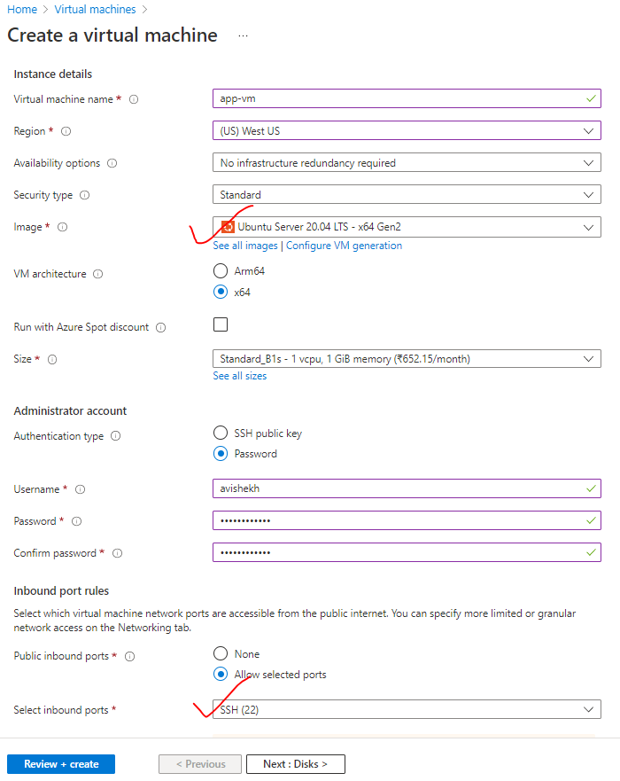

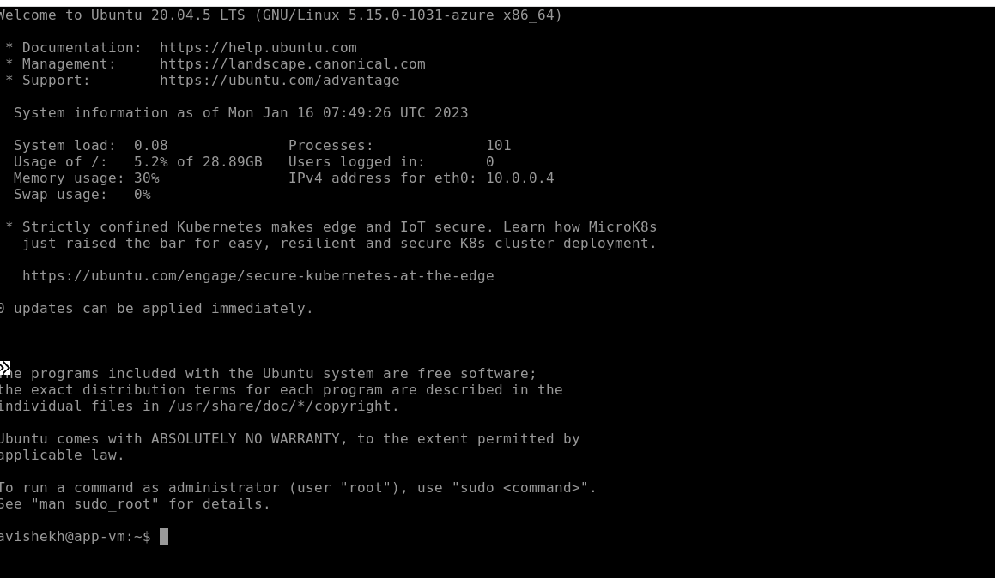

## Assignment 2

1. Create a Windows VM in West US region
2. Open the RDP port
3. Connect to it using Windows Remote Desktop

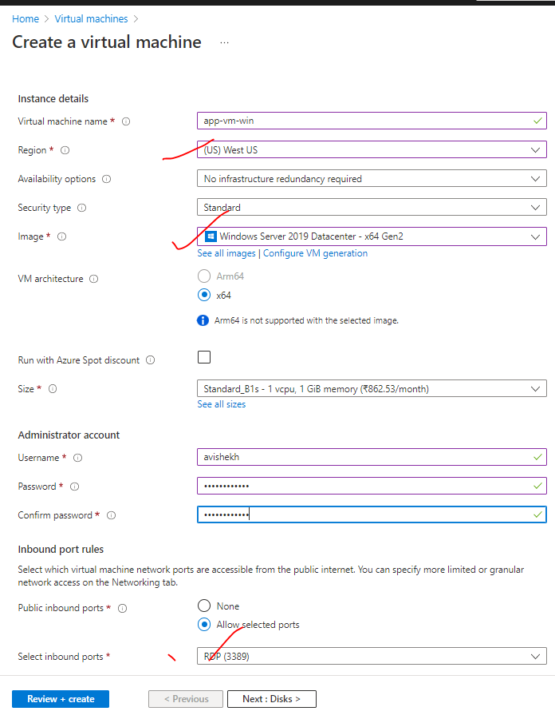

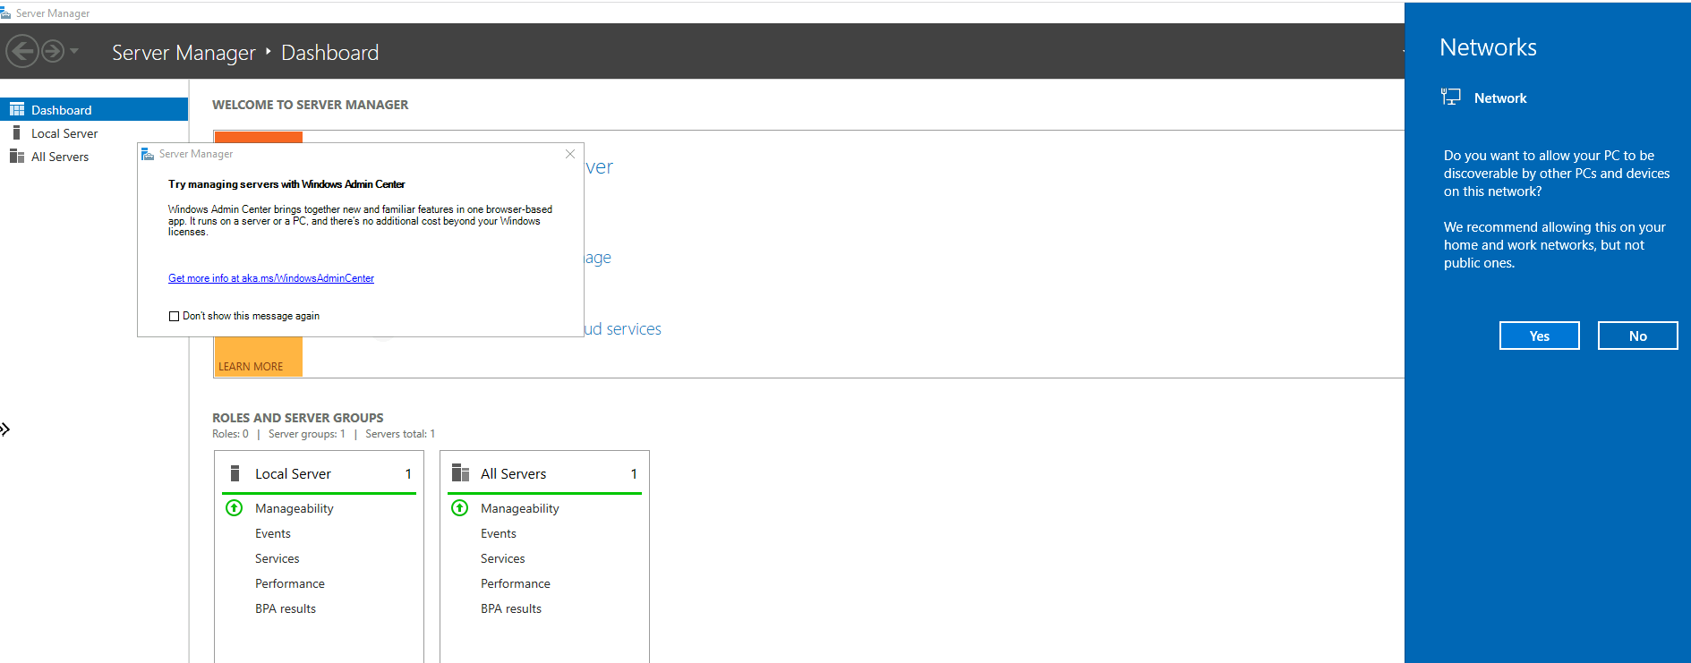

## Assignment 3

1. Create a VM scaleset with Ubuntu as OS
2. Give min VM’s as 1, and maximum as 5
3. For Scale-out CPU % is 75, and increase by 1 VM
4. For Scale-in CPU % is 25, decrease by 1 VM

|  |  |
| --- | --- |
| STEP 1 | STEP 2 |
|  | |

## Assignment 4

1. Create a Linux VM with ubuntu OS
2. Install apache2 software
3. Create image out of VM

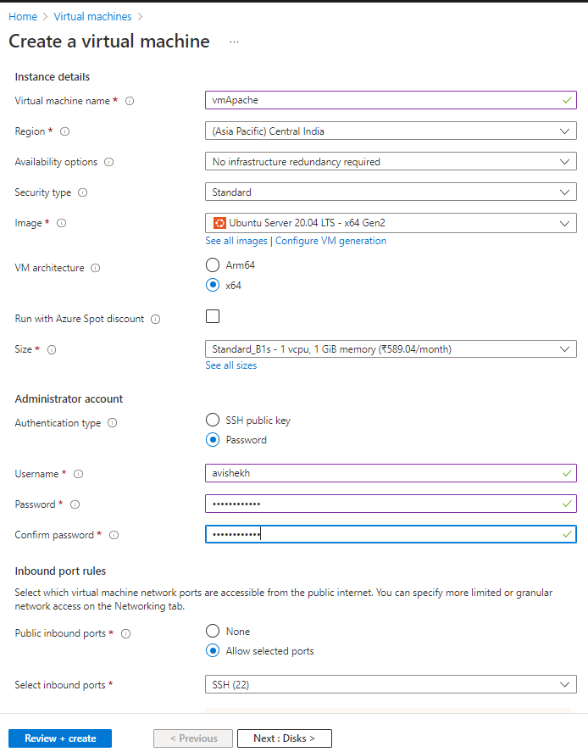

To Install Apache – We need to execute following command from the VM’s terminal

1. *sudo apt-get update*
2. *sudo apt-get install apache2*

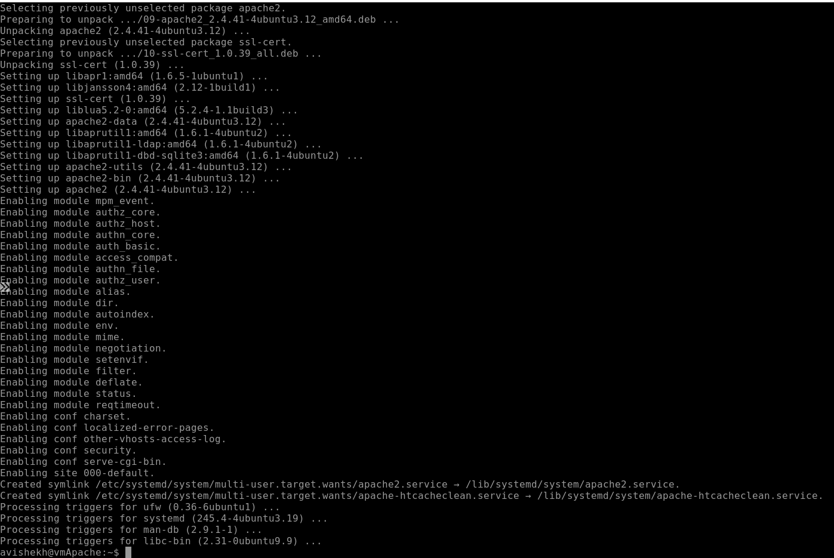

CREATING IMAGE

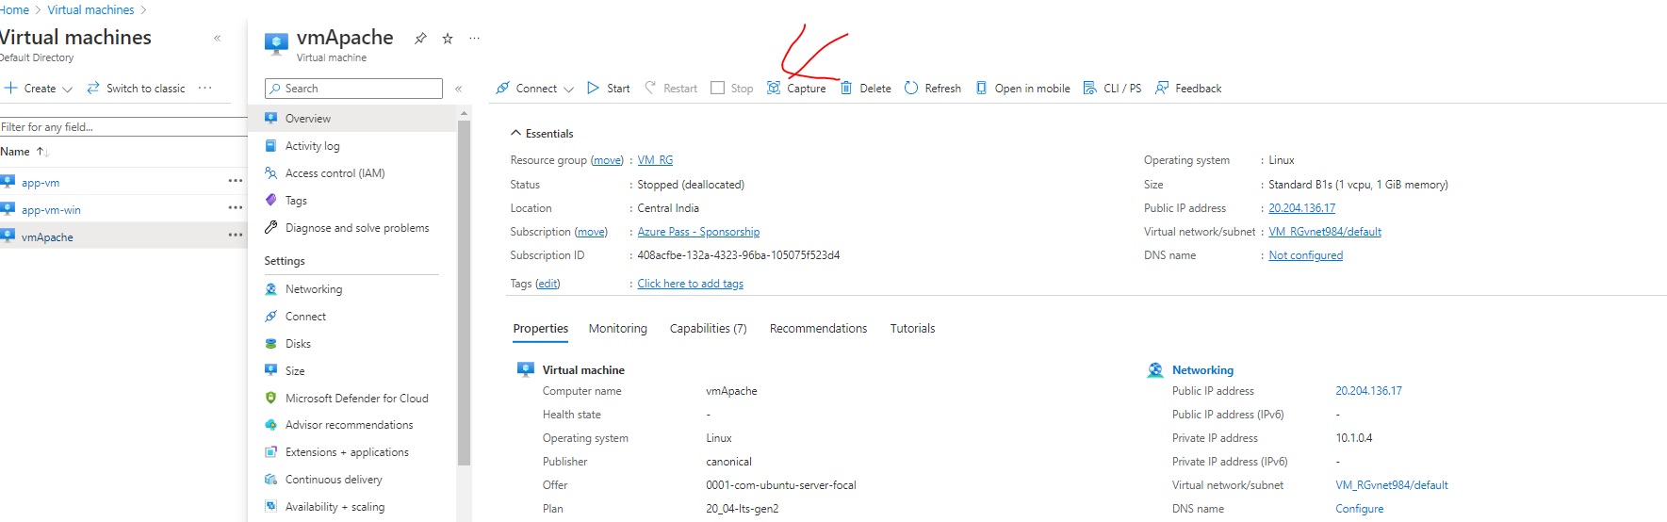

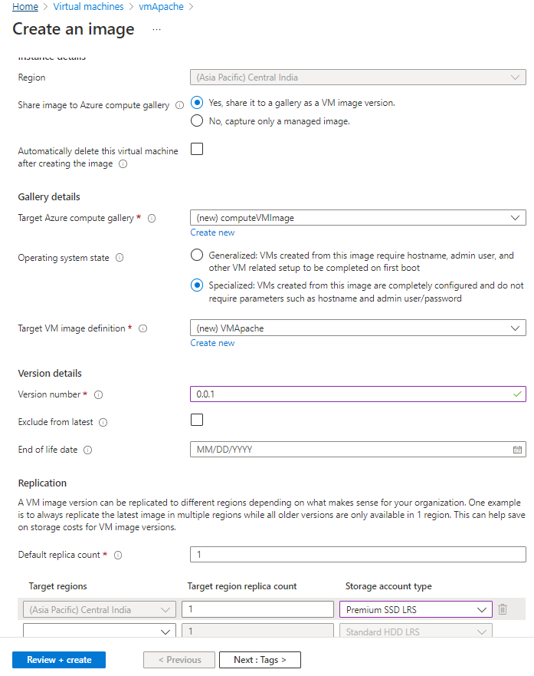

## Assignment 5

1. Deploy a VM from the previously created image
2. Open Port 80 in NSG
3. Start the apache2 service in the VM
4. Verify if you are able to access the website

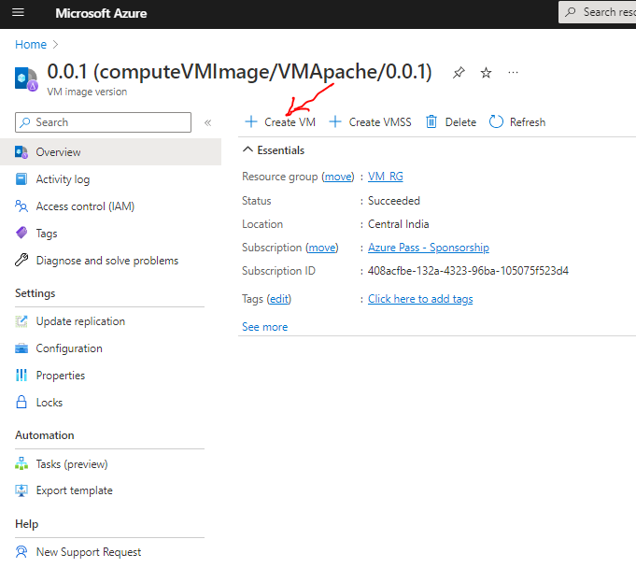

CREATING VM FROM IMAGE

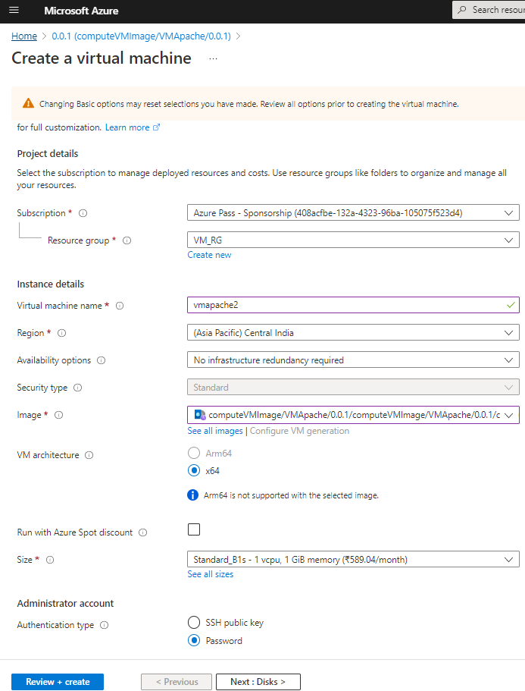

ADDING PORT TO NSG

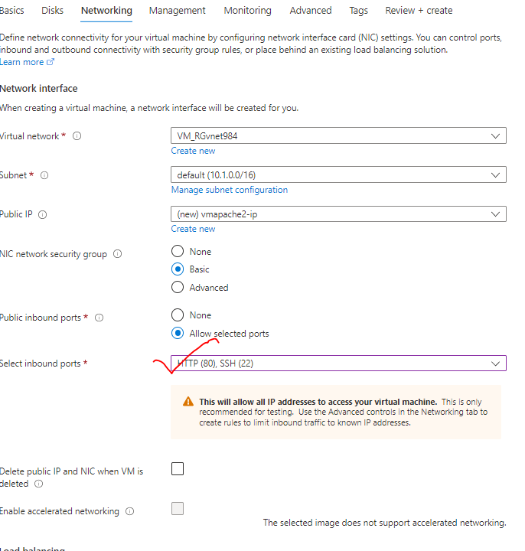

**ACCESSING APACHE HOME PAGE**

